Web Engineering
Mini Project

FledgLling

Developed by:
T.E. Div B
(Computer)

NAME | SAP ID
Sagar Vikmani | 60004120117
Vighnesh V. | 60004120116
Abhishek | 60004138015
Table of Contents

1.0 INTRODUCTION | 2
1.1 PURPOSE | 2
1.2 SCOPE OF PROJECT | 2
1.3 GLOSSARY | 3
1.4 OVERVIEW OF DOCUMENT | 4
2.0 OVERALL DESCRIPTION | 5
2.1 FUNCTIONAL REQUIREMENT SPECIFICATION | 5
2.2 USER CHARACTERISTICS | 6
2.3 NON FUNCTIONAL REQUIREMENTS | 6
2.4 MODELING DIAGRAM | 7
2.5 ARCHITECTURE | 10
2.6 SCREENSHOTS | 11

1.0. Introduction

1.1. Purpose
The purpose of this document is to present a detailed description of the Web Tutorial System. It will explain the purpose and features of the system, the interfaces of the system, what the system will do, the constraints under which it must operate and how the system will react to external stimuli. This document is intended for both the stakeholders and the developers of the system.

1.2. Scope of Project
This software system will be a Web Tutorial System for students studying for competitive exams. This system will be designed to maximize the students productivity by providing practice tests online to assist the students in computer based examinations, which would otherwise have to be solved manually using pen and paper. By maximizing the students solving speed and efficiency the system will meet the students needs while remaining easy to understand and use.
More specifically, this system is designed to allow a student to communicate with a group of experts in the respective fields by asking them doubts. The software will facilitate communication between students and experts via E-Mail. Preformatted reply forms are used in every stage so the students will come to know immediately whenever they have commited an error. The system also contains a relational database containing a list of competitive examinations.

1.3. Glossary
Term | Definition
GRE | An examination having two sections: Quant and Verbal which is given by students who wish to pursue their masters abroad
CAT | An examination having two sections: Quant and Verbal which is given by students who wish to pursue their MBA
Database | Collection of all the information monitored by this system.
Student | Person who has created an account in the system.
Field | A cell within a form.
Quant | .A Maths Test
Verbal | Test of vocabulary
Reader | Anyone visiting the site.
Expert | A person having proficiency in the given field.
Software Requirements Specification | A document that completely describes all of the functions of a proposed system and the constraints under which it must operate. For example, this document.
Stakeholder | Any person with an interest in the project who is not a developer.

1.4. Overview of Document
The following report of the project contains the overall description of the website, its various features and most importantly how it was implemented during the various stages of the project.

2.0. Overall Description

2.1 Functional Requirements Specification
- Easy navigation: This website will have a very easy and self-explainable interface. The links will be easy to understand and indicated in different styles or colours. There will be no broken links and the user can navigate to any page from his current page
- Self-explainable interface: The language used in the user interface will be simple English and easy to understand with a very few jargons.
- Form related validation: The student may be required to fill forms for accessing or creating an account on the website. We have used JavaScript form Validation to check if all the fields have been filled correctly.
- Score Calculation: After submitting the test, the students score will be calculated automatically using JavaScript code and explanations will be provided to all the questions.

2.2 User Characteristics
The student is expected to be Internet literate and be able to give tests online. The main screen of the Online Tutorial Website will have a link to tests for respective examinations.
The student is also expected to be Windows literate and to be able to use button, pull-down menus, and similar tools.

2.3 Non-Functional Requirements
The Online Tutorial will be on a server with high speed Internet capability. The software developed here assumes the use of a tool such as Xampp for connection between the Web pages and the database. The speed of the students connection will depend on the hardware used rather than characteristics of this system.
The student will also get an acknowledgement whenever he asks questions to the experts that the email has been sent.
- Support:
Browser: Google Chrome, Internet Explorer, Mozilla Firefox
Operating System: Windows
- Software used: Notepad++, Google Chrome Browser
- Languages used: JavaScript, CSS, HTML,
- Requirements: Mouse or Trackpad, Keyboard

2.4 Modeling Diagrams
2.4.1 Used Case Diagram: It describes the various uses of the website with respect to the student.
Register
Student
Ask Expert
Give Tests
Submit Test
View explanation

2.4.2 Activity Diagram: It gives a detailed flowchart of various activities that can be performed on the website. The activity of attempting a test paper is given below:

Student
chooses
Submit?
Score display
Return to Test Paper
Test Paper
yes

no

2.4.3 Class Diagram: It describes the various classes present in the system and how they are related to each other.
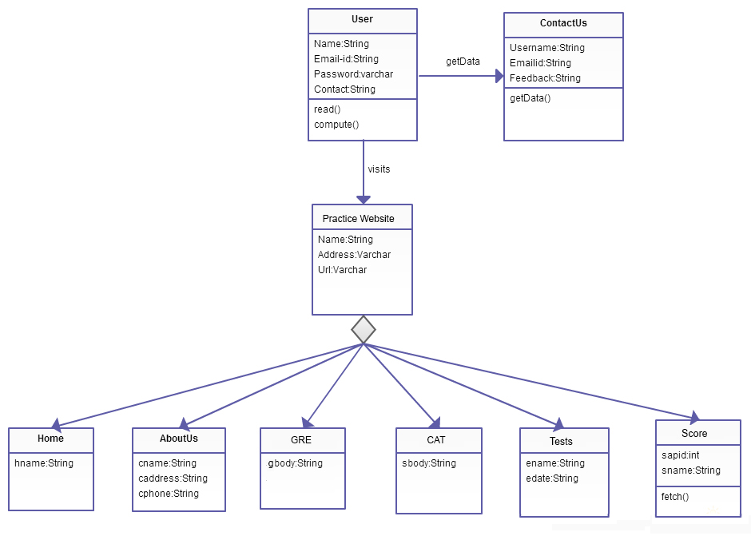

2.5 Architecture
The architecture of the web application shows the various software and hardware components and various machines that are in use for successful running of the web application. The various components required for our web application are shown in the diagram below.

Browser
Client
Firewall/Proxy
Web Server/Application Server/ Database Server

2.6 Screenshots

